# C:\Users\Robin\AppData\Local\Microsoft\Windows\INetCache\Content.Word\il_fullxfull.808464833_7b7a.jpg

REQUIREMENTS

DOCUMENT

ITRW213

ANALYSIS PARALYSIS

RB DE KLERK

NJ ROBERTS

FJ VERSTER

AY PATEL

Table of Contents

[1](#_Toc478657557)

[Table of Figures 2](#_Toc478657558)

[SCOPE 3](#_Toc478657559)

[Product 3](#_Toc478657560)

[Quality 3](#_Toc478657561)

[Time 3](#_Toc478657562)

[Cost 3](#_Toc478657563)

[Resources 3](#_Toc478657564)

[Definitions 4](#_Toc478657565)

[PROJECT DESCRIPTION 4](#_Toc478657566)

[REQUIREMENTS 5](#_Toc478657567)

[Functional requirements 5](#_Toc478657568)

[Inputs: 5](#_Toc478657569)

[Outputs: 5](#_Toc478657570)

[Processes: 5](#_Toc478657571)

[Stored data: 5](#_Toc478657572)

[Non-functional requirements 6](#_Toc478657573)

[Candidate Systems Matrix 8](#_Toc478657574)

[Feasibility analysis matrix 9](#_Toc478657575)

[Use case 10](#_Toc478657576)

[Glossary 10](#_Toc478657577)

[Diagram 12](#_Toc478657578)

[Examples of data, questionnaires, fact-finding techniques used 13](#_Toc478657579)

[Summary 14](#_Toc478657580)

# Table of Figures

Figure 1 7

Figure 2 7

Figure 3 13

# SCOPE

## Product

This requirements document is for Chalique nail studio for a new information system.

This information system needs to:

* make bookings,
* cancel bookings,
* adjust bookings,
* notify clients of upcoming bookings,
* print financial statements,
* keep a database of clients and products,
* keep track of sales and other expenditure
* The system should also enable future communication between the different businesses as the owner is looking to expand in the future.

## Quality

* The system should be designed to be simple to use for employees who are not familiar with computers.
* It should also be available every day of the week.
* It should be secure with a password system to access financial data.
* It should be designed in a similar way to Windows applications.

## Time

The system must be completed, tested and implemented within a year.

Any additions to the project will be scheduled for an additional phase and will affect the time and cost of the system.

## Cost

The budget must be kept minimal as the system is for a very small 2-man business.

## Resources

Four system analysts working together on all aspects of the system development process for the specified system. Services such as quality checks will be conducted throughout system development by means of peer review. Supplies and materials used will include computers and corresponding design software, a printer to test the financial statement system.

## Definitions

**Database** –a set of records stored on a computer in a systematic way for a program to answer questions.

**Functional requirement** – a description of activities and services a system must provide, including inputs, outputs, processes and stored data

**Nonfunctional requirement** – a description of other features, characteristics, and constraints that define a satisfactory system.

**Use case** – a behaviorally related sequence of steps (e.g. the scenario), both automated and manual, for the purpose of completing a single business task.

**Free-format questionnaire** – a questionnaire designed to offer the respondent greater latitude in the answer. A question is asked, and the respondent records the answer in the space provided after the question.

**Fixed-format questionnaire** – a questionnaire containing questions that require selecting an answer from predefined available responses.

**Gantt chart** – a bar-chart that depicts projects against a calendar.

# PROJECT DESCRIPTION

*Chalique Nail Studio* is a nail salon owned by two entrepreneurs in Johannesburg and is in dire need of a new information system. At present, all documentation and sales are done by hand, bookings and transactions are noted in a diary. It is currently a micro business looking to expand in the future. Ordering new stock is done manually when products are needed.

The aim of this project is to design a system to simplify the booking and sales process and keep better track of the clients’ details and backup systems.

# REQUIREMENTS

## Functional requirements

### Inputs:

As shown in figure 1 the inputs for making an appointment include:

* Client name
* Time and date of the appointment
* Selection of treatments

For the sales section inputs will also include:

* Products used
* Cost of treatment

### Outputs:

As shown in figure 2 the outputs include:

* List of bookings ordered by day for a 5-day period
* Information of a selected booking including appointment and treatment details
* Options to add, edit and cancel bookings

Financial statement generated on demand with monthly, quarterly or yearly details.

### Processes:

* Add to and edit bookings in the database
* Add sales to a sales database
* Add clients to a clients’ database and edit details
* Stock management

### Stored data:

Clients database:

* Client name
* Client cell number
* Email address

Bookings database:

* Date and time of booking
* Treatments
* Cost
* Client name

Sales database:

* Treatments
* Payment method
* Booking reference
* Cost

Treatments database:

* Treatment description
* Products used
* Treatment cost
* Time required

Stock database:

* Product name
* Amount

Expenses database

* Expense description
* Amount

## Non-functional requirements

Based on the PIECES framework:

* Access level for different users to prevent access to financial data by unauthorized users.
* No training required
* Budget:
  + Estimated salary of a system analyst per year: R 360 000
  + Breakdown: R170 p/h for 8-hours p/d 260-days p/y (Monday to Friday, 8-hour workday)
  + Estimated salary for entry level system analyst per year: R 310 000
  + Breakdown: R150 p/h for 8-hours p/d 260-days p/y (Monday to Friday, 8-hour workday)
  + Work time required: 2-hours p/d 5-days p/w for 36 weeks
  + Maximum Estimate: R150 p/h pp x 360 hours x 4 analysts = R 216 000
  + Minimum estimate: R 100 000.
* The development and implementation must be completed by 25 October 2017
* Easy to maintain

Figure 1: Proposed appointment input form

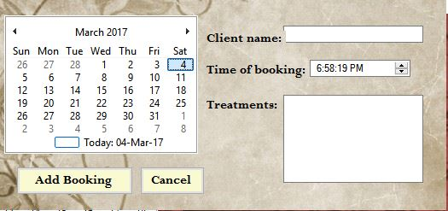Figure 1

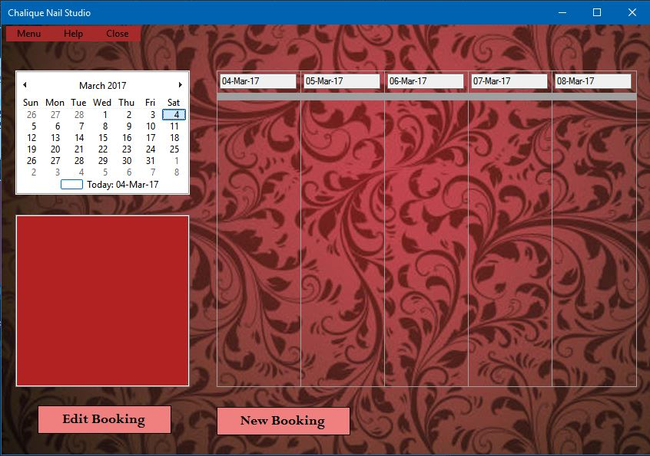*Figure 2: Proposed main form*

Figure 2

# Candidate Systems Matrix

|  |  |  |  |
| --- | --- | --- | --- |
| **Characteristics** | **Candidate 1** | **Candidate 2** | **Candidate 3** |
| **Stakeholders**  How the system will interact with people and other systems | MS Access and C# | MSSQL and C++ | Same as candidate 2 |
| **Knowledge**  How data will be implemented, captured and output  (description of input, output and implementation methods/devices) | Client to server  Keyboard and mouse  Printer and pdf | Same as Candidate 1 | Same as Candidate 1 |
| **Processes**  How processes will be built and implemented  (software and tools, services and workstations) | MS Visual Studio 2015 and MS Access 2016 | Same as Candidate 1 | Same as Candidate 1 |
| **Communication**  How processes and data will be distributed  Application software  Storage devices | Custom solution  Hard drive, backup drive | Custom solution  Hard drive, remote server | Custom solution, Cloud storage |

# Feasibility analysis matrix

|  |  |  |  |  |
| --- | --- | --- | --- | --- |
| Feasibility Criteria: | **Weight:** | **Candidate 1** | **Candidate 2** | **Candidate 3** |
| Description: |  | Write new application in-house using C# and MS Access database | Write new application in-house using C++ and MS SQL database | Same as Candidate 2 |
| Operational Feasibility: | 15% | Client requirements and functionality are fully supports  Score:100 | Support for most of client requirements and some functionality. Concerns about ease of use.  Score: 60 | Supports minimal requirements. Unsuited for functionality required.  Score: 30 |
| Cultural Feasibility: | 15% | No foreseeable problems  Score: 100 | Alternate interface may not suit user  Score: 70 | No foreseeable problems  Score: 100 |
| Technical Feasibility: | 20% | Works well, exceptions include minor bugs in input, unexpected crashes, long startup time  Score: 80 | Works flawlessly, no bugs but may crash under strain  Score: 90 | Works perfectly  Score: 100 |
| Economic Feasibility:  Cost to develop:  Payback:  Detailed calculations: | 30% | R 216 000  48 months  See project proposal report  Score: 90 | R 380 000  3 years  -  Score: 40 | R 120 000  Within 1 year  -  Score 95 |
| Schedule Feasibility: | 10% | Less than 1 year  Score: 80 | 18 – 30 months  Score: 50 | 9 months  Score: 90 |
| Legal Feasibility: | 10% | No foreseeable problems  Score: 100 | No foreseeable problems  Score: 100 | No foreseeable problems  Score: 100 |
| Weighted Score: | 100% | 91% | 65% | 87% |

Candidate system 1 scored the highest in the feasibility matrix and has thus been accepted as the most appropriate solution.

# Use case

## Glossary

|  |  |  |
| --- | --- | --- |
| **Use-Case Name** | **Use-Case Description** | **Participating Actors and Roles** |
| Make booking | This use-case describes the event of making a new booking. | Owner  Employees |
| Edit booking | This use-case describes the event of altering an existing booking. | Owner  Employees |
| Cancel booking | This use-case describes the event of cancelling a booking. | Owner  Employees |
| Load bookings | This use-case describes the event of loading a set of bookings into the interface. | Owner  Employees |
| Repeat booking | This use-case describes the event of making a booking for a set number of repetitions | Owner  Employees |
| View all bookings | This use-case describes the event of loading and displaying all current bookings. | Owner |
| Booking detail view | This use-case describes the event of viewing details of a specific booking. | Owner  Employees |
| Payment | This use-case describes the event of the booking payment. | Owner  Employees |
| Add expense | This use-case describes the event of adding a business expense | Owner |
| Generate statement | This use-case describes the event of creating a financial statement based on the selected period. | Owner |
| Take stock | This use-case describes the event of taking stock of available supplies. | Owner  Employees |
| View stock | This use-case describes the event to view all available stock. | Owner  Employees |
| Add treatment | This use-case describes the event of adding a treatment to the database | Owner |
| Notify for booking | This use-case describes the event of sending a notification about the booking to the client | User |
| Login | This use-case describes the event of a user logging in to access financial data | Owner |

## C:\Users\Robin\AppData\Local\Microsoft\Windows\INetCache\Content.Word\Use-case Diagram.jpgDiagram

# Examples of data, questionnaires, fact-finding techniques used

Some methods used:

* Questionnaires:
  + Free format questionnaire
  + Fixed format questionnaire
* Sampling of existing documentation
  + Gantt chart
  + Product list
  + Price list
  + 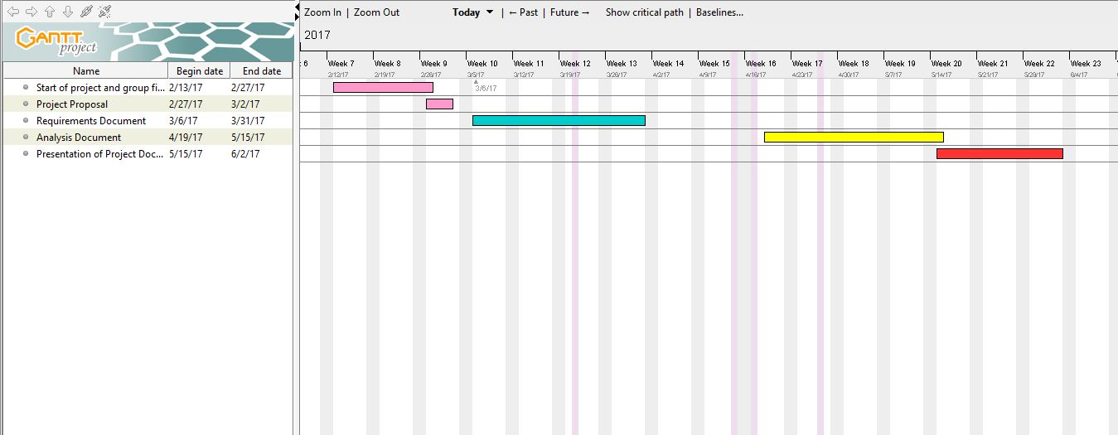Weekly booking example (see folder “One week bookings”)

Figure 3

For questionnaire and Gantt chart details please refer to the attached folder “Appendix.”

# Summary

This requirements document contains the requirements as needed for the development of the information system for Chalique Nail Studio which currently has no information system. We have added some functionality according to both client and system requirements. A use-case model diagram has been added for ease of understanding processes and methods, as well as which stakeholders have access to them. Additional documentation has been added containing all sampling data (see folder “Appendix”).